**Measure energy consumption**

**Introduction:**

Measuring energy consumption is a critical aspect of understanding and managing our energy resources. Whether in the context of a household, a commercial establishment, or an industrial facility, the ability to quantify and analyze energy usage is essential for sustainability, cost control, and environmental responsibility. In this discussion, we will explore the various methods and tools available for measuring energy consumption, highlighting their importance in promoting energy efficiency and reducing our carbon footprint. Measuring energy consumption involves a more in-depth process that includes the following details:

1. **Energy Meters:** Energy meters, such as electricity meters or gas meters, are essential devices used to measure energy consumption. These meters record the amount of energy consumed over a specific period.
2. **Data Collection:** Energy meters collect data on energy usage and provide this information in various units, such as kilowatt-hours (kWh) for electricity or cubic feet for gas.
3. **Real-time Monitoring:** Advanced systems can provide real-time data, allowing users to monitor energy consumption continuously and make immediate adjustments.
4. **Submetering:**n large facilities, submetering is used to measure energy consumption for different areas or equipment. This helps identify energy hogs and opportunities for improvement.
5. **Sensor Technology:** Sensors, like temperature sensors and occupancy sensors, can provide additional data to correlate energy usage with environmental conditions and occupancy patterns.
6. **Data Analysis:** Energy consumption data is analyzed to identify trends, peak usage times, and areas where energy-saving measures can be applied.
7. **Energy Audits:** Professional energy audits are conducted to assess a building's energy performance comprehensively. They can involve on-site inspections, data analysis, and recommendations for improvements.
8. **Energy Management Software:** Specialized software is used to process and visualize energy consumption data, making it easier to manage and optimize energy use.
9. **Energy Conservation Measures:** energy consumption is measured and analyzed, appropriate measures can be taken to reduce consumption, such as upgrading equipment, improving insulation, or changing energy usage patterns.
10. **Regulatory Compliance:** depending on the location and industry, there may be regulations and standards that require energy consumption monitoring and reporting.
11. **Renewable Energy Integration:** Some systems measure not only consumption but also the production of renewable energy sources, like solar panels, to determine the overall energy balance.

In essence, measuring energy consumption is a comprehensive process that involves the use of various tools, technologies, and data analysis to gain insights into how energy is used and to find ways to optimize its use efficiently.

**Outline problem statement :**

The problem statement for measuring energy consumption can be outlined as follows:

**problem Statement:** in today's world, energy consumption plays a critical role in our daily lives, industries, and the global economy. However, inefficient energy use, rising energy costs, and environmental concerns have brought to light the need for accurate and comprehensive methods to measure and manage energy consumption. The problem can be summarized in the following key points:

1. **Lack of Accurate Measurement:** Many consumers, businesses, and industrial facilities do not have accurate and up-to-date methods for measuring their energy consumption. This leads to uncertainty about how much energy is being used and where it is being consumed.
2. **Energy Waste:** Inefficient energy use is a significant issue, resulting in both unnecessary financial costs and environmental impacts. Without precise measurements, identifying areas of waste and implementing energy-saving measures becomes challenging.
3. **Environmental Impact:** Excessive energy consumption contributes to increased carbon emissions and other environmental concerns. Without effective measurement, it is di cult to track progress in reducing these impacts and meeting sustainability goals.
4. **Cost Control:** Escalating energy costs can strain budgets for households and businesses. Accurate measurement is essential for budgeting and identifying cost-effective strategies to reduce energy expenses.
5. **Regulatory Compliance:** Many regions have regulations and standards in place to limit energy consumption and promote sustainability. Accurate measurement is necessary to ensure compliance with these regulations.
6. **Data Utilization:** While data on energy consumption is abundant, effectively utilizing this data to make informed decisions and drive energy efficiency improvements remains a challenge.
7. **Technological Advancements:** Advancements in energy technology, such as renewable energy integration and smart grids, require precise energy measurement to assess their impact and optimize their use.

The problem statement revolves around the need for accurate, accessible, and actionable information on energy consumption to enable individuals, businesses, and industries to reduce waste, control costs, meet environmental goals, and comply with regulations.

Addressing this problem is crucial for a sustainable and energy-efficient future.

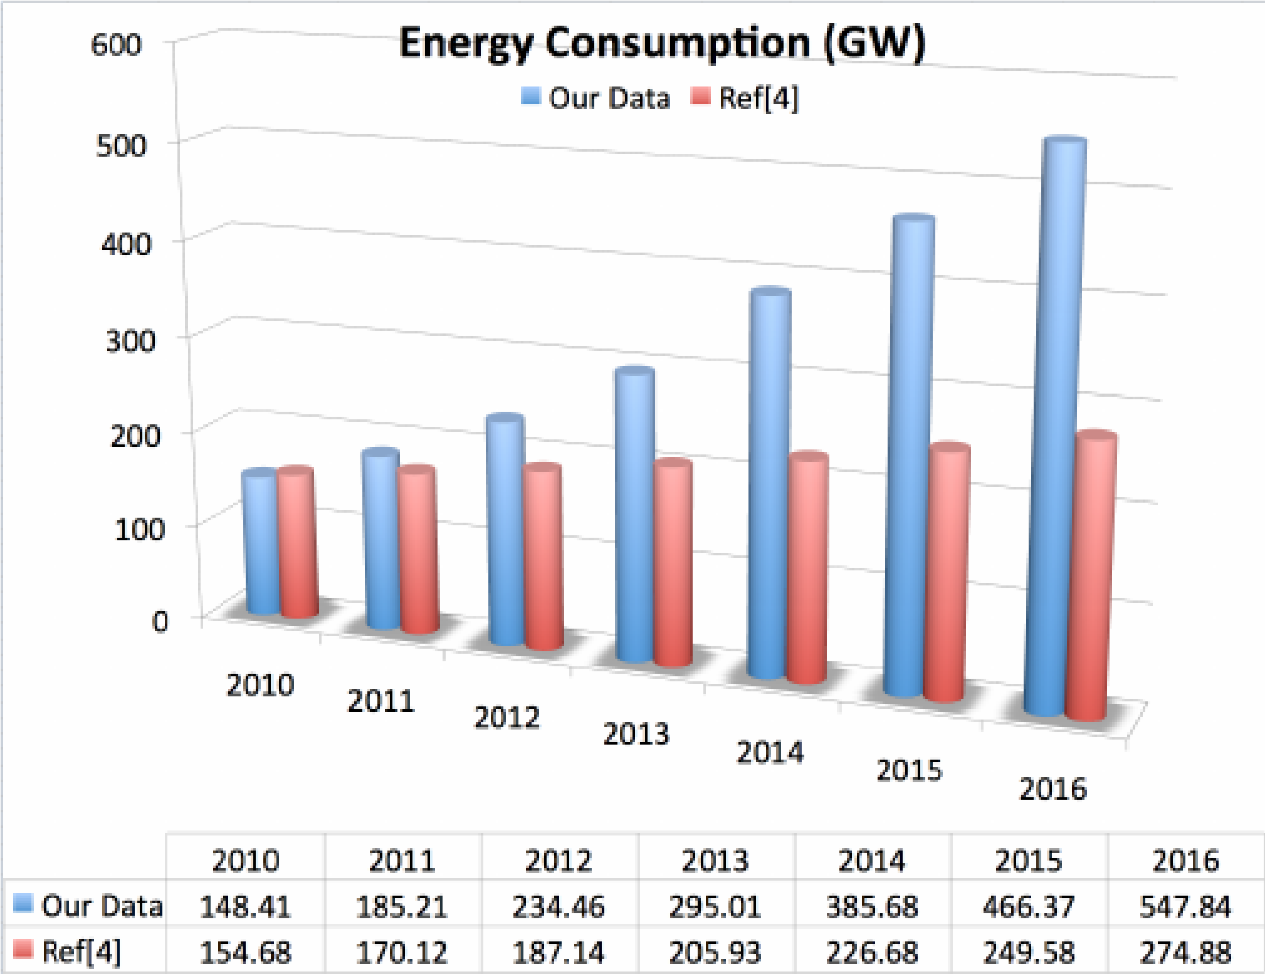

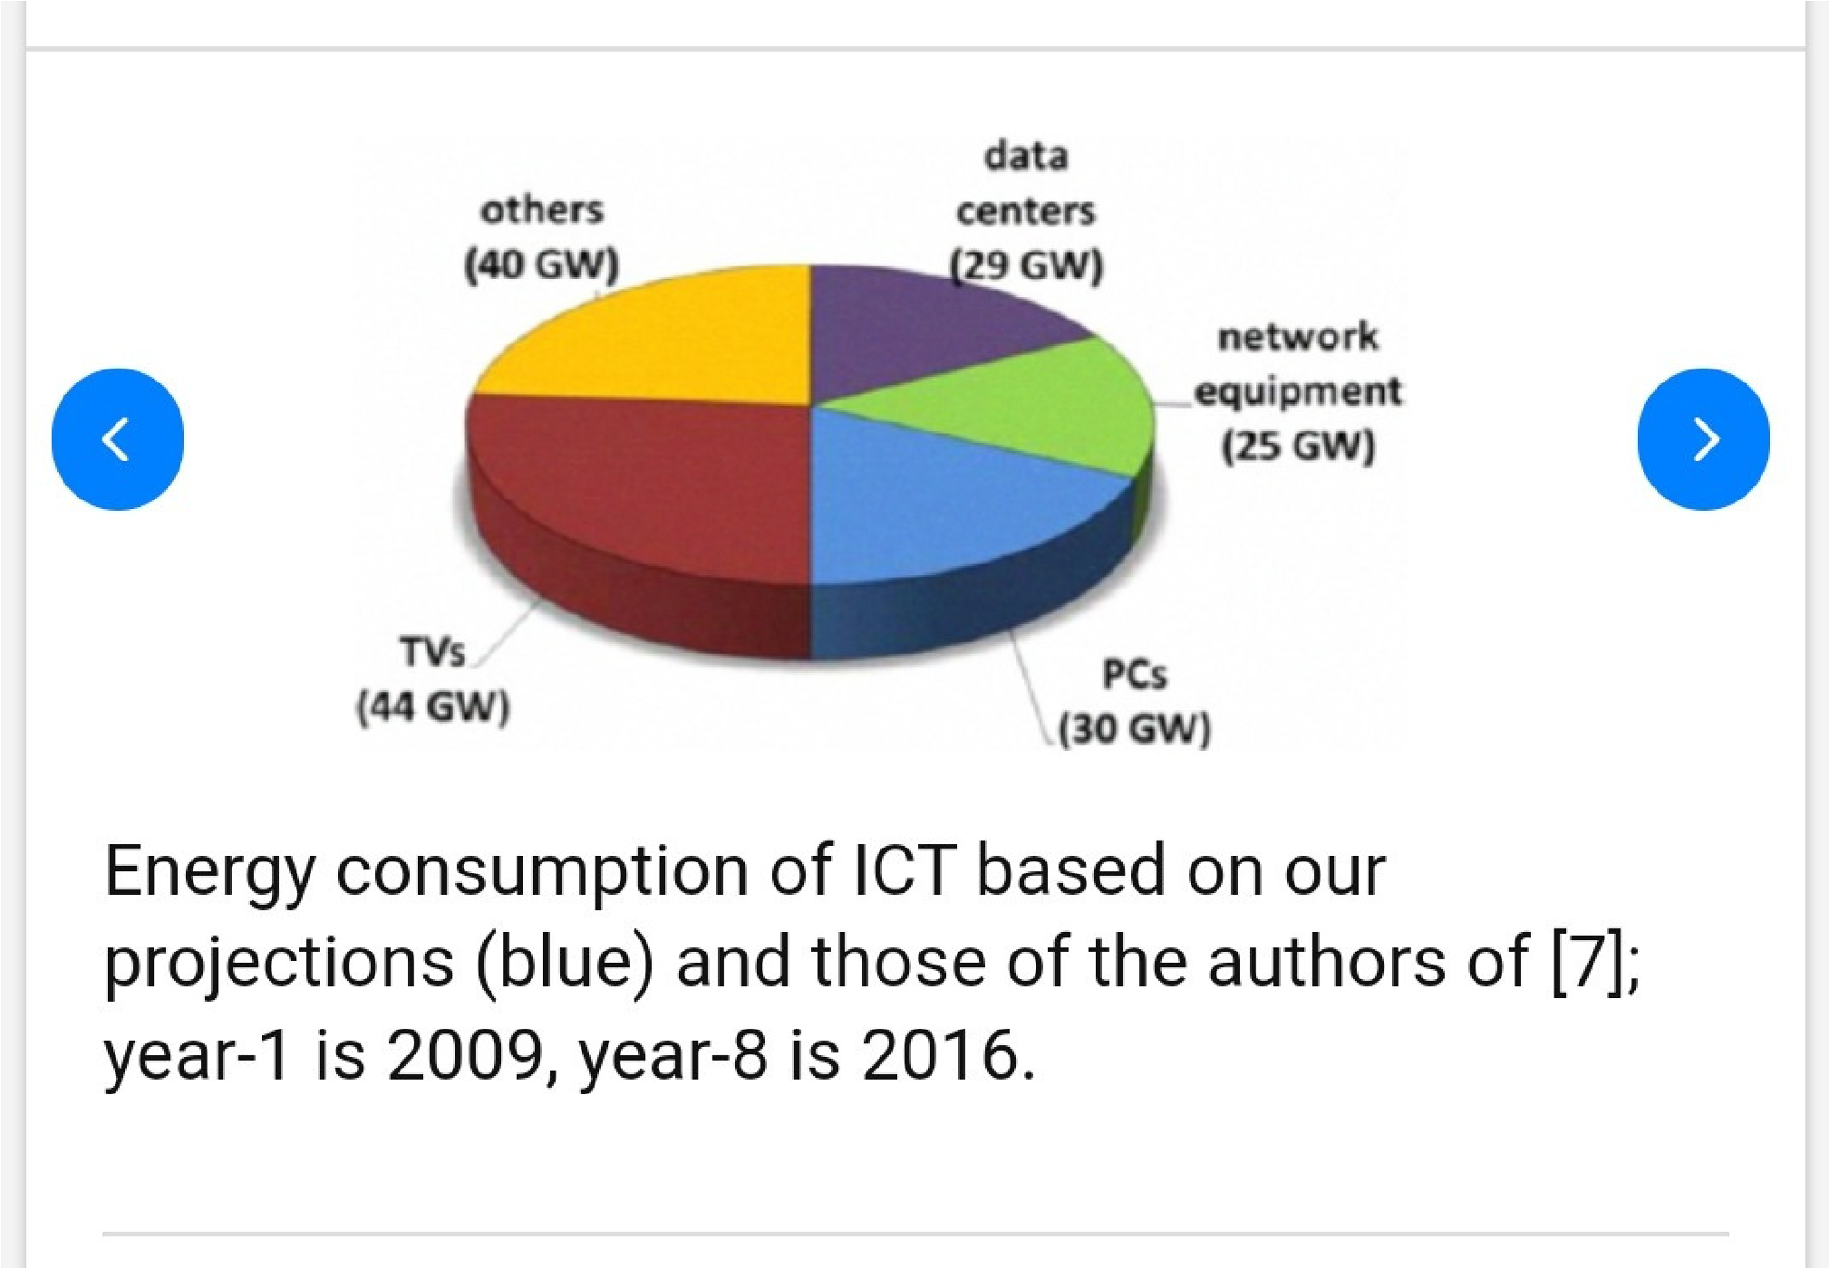

**Design thinking energy consumption:**

Design thinking is a human-centred approach to problem-solving and innovation that can be applied to various fields, including the development of solutions for measuring energy consumption. The design thinking process typically involves five key phases:

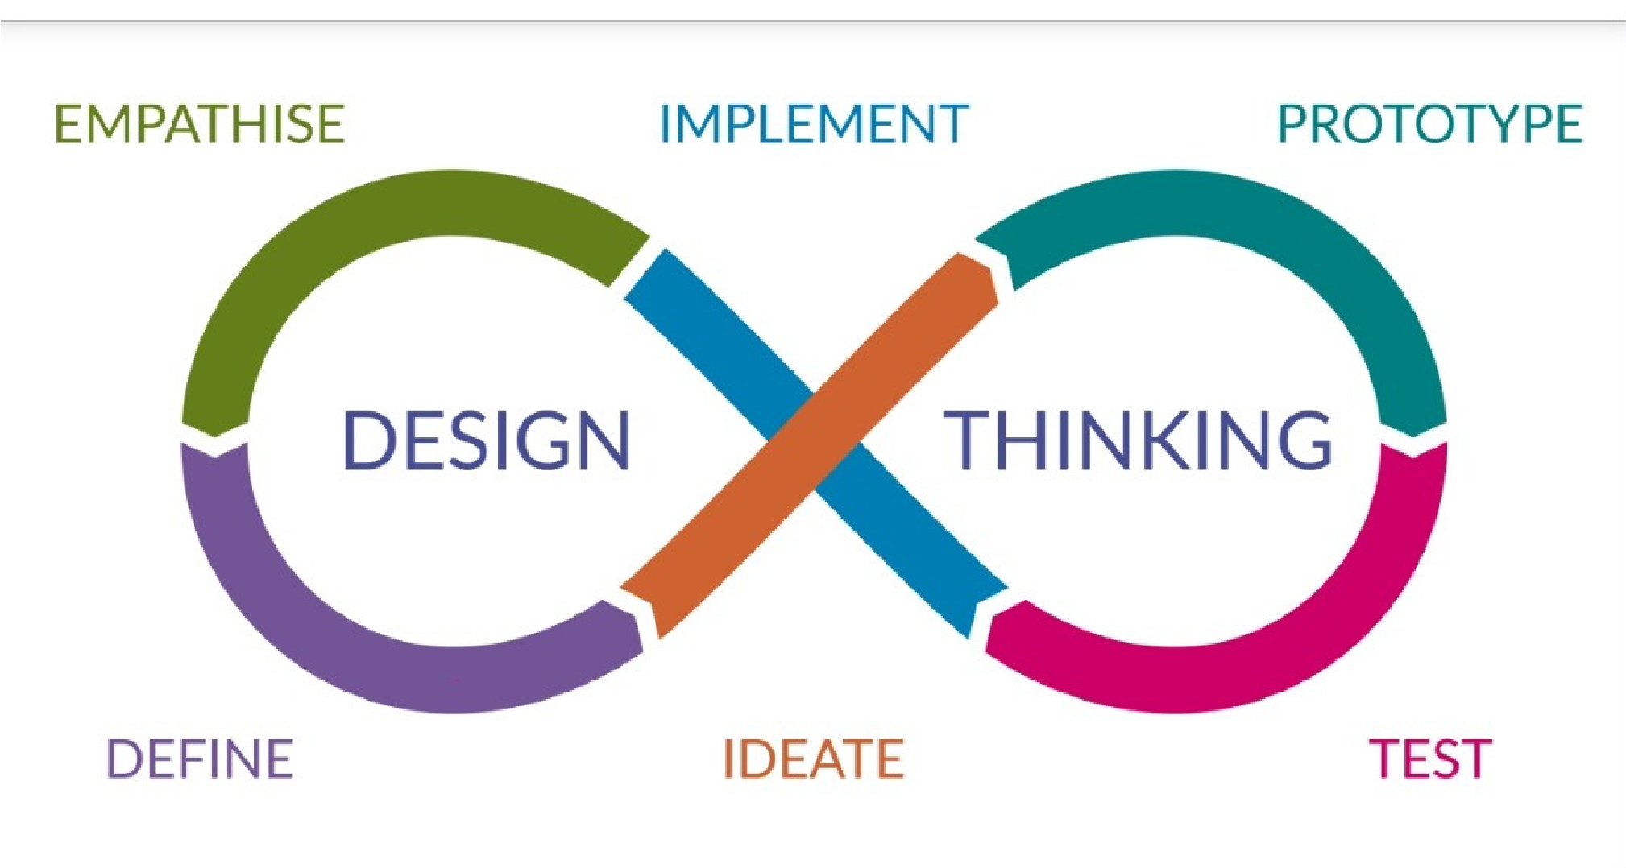

1. **Empathize:** In this phase, you would seek to understand the needs and challenges of the users and stakeholders involved in energy consumption measurement. This could include homeowners, businesses, utility companies, and regulatory bodies. It's essential to conduct interviews, surveys, and observations to gain empathy and insights into their perspectives.
2. **Define:** Based on the empathy gained in the previous phase, you would define a clear problem statement or design challenge related to measuring energy consumption. This step involves synthesizing the information gathered to identify the specific pain points and opportunities for improvement.
3. **Ideate:** In this creative phase, you generate a wide range of ideas for addressing the defined problem. This could involve brainstorming sessions, ideation workshops, and encouraging "out-of-the-box" thinking to propose innovative solutions for measuring energy consumption more accurately and effectively.
4. **Prototype:** Once you've selected promising ideas from the ideation phase, you create prototypes or mock-ups of the proposed solutions. For energy consumption measurement, this might involve designing user interfaces for energy monitoring systems, developing physical measurement devices, or simulating data analytics tools.
5. **Test:** Testing is a crucial phase where you gather feedback on your prototypes. You involve users and stakeholders in the testing process to see how well the proposed solutions meet their needs. Iteration is common in this phase, allowing you to refine and improve the solutions based on user feedback.

The development phase for measuring energy consumption typically follows the design thinking process and may include stages like:

**6.Development:** After validating the prototypes and concepts through testing, you move into the development phase. This involves building the actual products or systems for measuring energy consumption, which could include hardware, software, or a combination of both.

1. **Testing and Validation:** Rigorous testing is conducted on the developed solutions to ensure they perform accurately, reliably, and meet relevant industry standards. Data collected during this phase helps refine the solutions further.
2. **Deployment:** Once the solutions are tested and validated, they are deployed in the target environments. For example, energy meters, sensors, or software may be installed in homes, businesses, or industrial facilities to start measuring energy consumption.
3. **Monitoring and Optimization:** Continuous monitoring of the deployed solutions is essential to ensure they perform as expected. Data analysis is used to identify opportunities for optimization and to make adjustments as needed.
4. **User Training and Adoption:** Users and stakeholders are trained to effectively use the new energy measurement solutions, and strategies for promoting adoption are implemented.
5. **Feedback Loop:** An ongoing feedback loop is established to collect user feedback and address any issues or improvements required in the deployed solutions.

The design thinking process ensures that the development of energy consumption measurement solutions is user-centred and addresses real-world needs effectively. This approach can lead to more innovative, accurate, and user-friendly solutions for measuring and managing energy consumption.

**Development phase for measure energy consumption:**

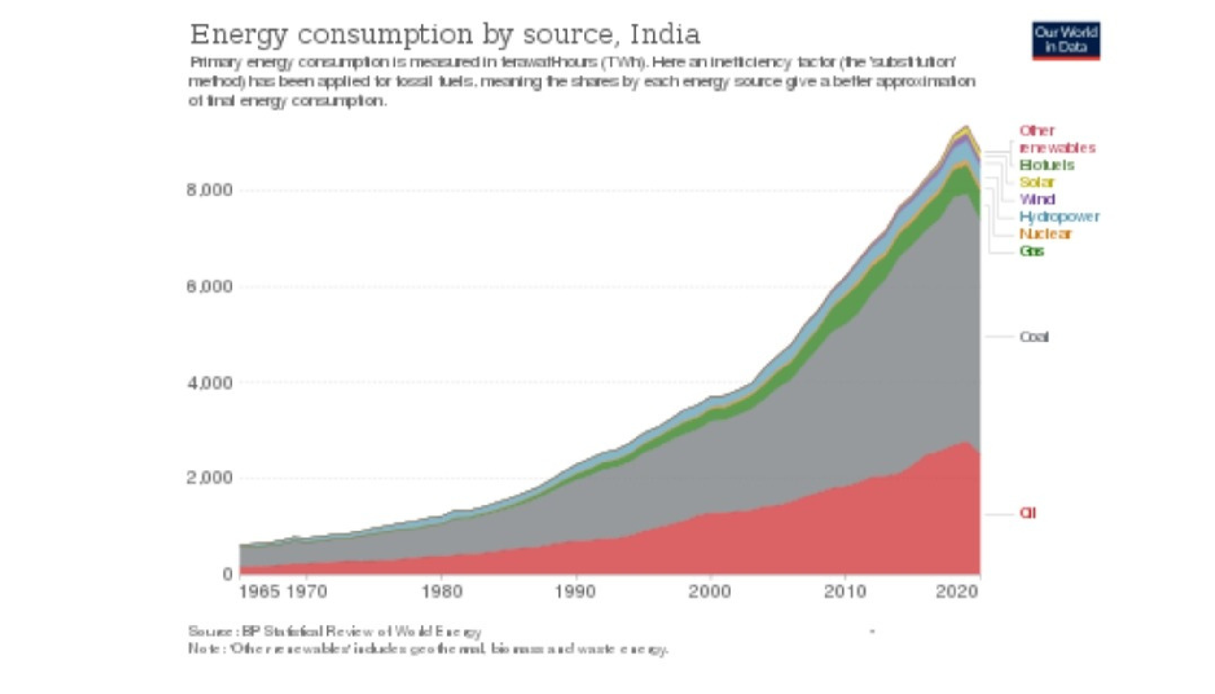

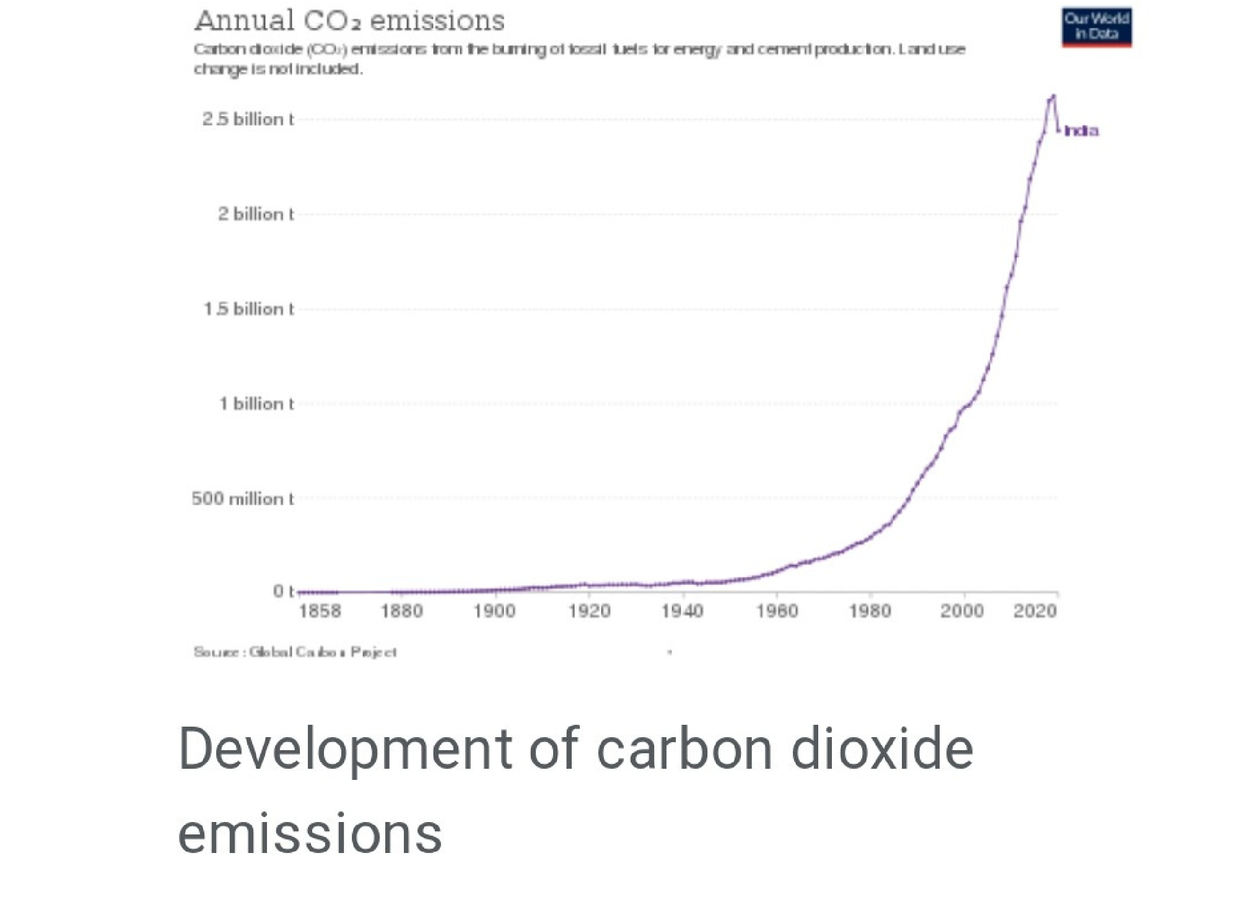

The development phase for measuring energy consumption involves the practical implementation of the solutions designed to address the challenges in energy measurement.

This phase typically includes the following stages:

1. **Technical Design:** Detailed technical specifications are developed for the energy measurement solution. This includes the selection of appropriate hardware, software, sensors, and data collection methods. Technical architecture and system design are established to ensure the accurate and reliable measurement of energy consumption.
2. **Prototype and Proof of Concept:** Prototypes of the energy measurement systems are created to validate the technical design. These prototypes help identify any technical challenges and allow for adjustments and improvements before full-scale development.
3. **Software and Hardware Development:** Depending on the nature of the solution, the development of both software and hardware components may be necessary. This could involve creating user interfaces, programming data analysis algorithms, and manufacturing physical measurement devices.
4. **Integration and Testing:** All components, whether hardware or software, are integrated to create a complete energy measurement system. Thorough testing is conducted to ensure the accuracy, reliability, and functionality of the system. This testing may involve various scenarios to mimic real-world conditions.
5. **Compliance and Standards:** Energy measurement systems often need to adhere to specific industry standards and regulatory requirements. Compliance testing and certification processes are performed to ensure that the solution meets these standards.

**6.DataManagementandStorage:**Solutions often involve the collection and storage of substantial amounts of data. Robust data management and storage systems are developed to securely store and manage this information.

1. **Security Measures:** Given the sensitivity of energy consumption data, robust security measures are implemented to protect against data breaches and unauthorized access.
2. **Scalability:** Considerations for scalability are important, as the system may need to accommodate additional sensors, users, or increased data loads as it is deployed in larger or more complex environments.
3. **User Training:** Training materials and programs are developed to educate users and stakeholders on how to use the energy measurement system effectively. This includes understanding data reports, interpreting results, and implementing energy-saving measures.
4. **Deployment Planning:** well-defined plan for deploying the energy measurement system in the intended environment is established. This includes logistics, installation, and rollout strategies.
5. **Documentation:** Comprehensive documentation is created, including user manuals, technical guides, and maintenance instructions, to support users and maintenance teams.
6. **Quality Assurance:** Rigorous quality assurance processes are in place to ensure that the energy measurement system functions reliably and accurately.
7. **Pilot Testing:** Before a full-scale deployment, a pilot testing phase is often conducted to validate the system's performance in a real-world setting. This helps uncover any unforeseen issues and allows for refinements.
8. **Full Deployment:** Once the system has passed all testing and validation stages, it is deployed in the target environments, such as homes, businesses, or industrial facilities.
9. **Post-Deployment Support:** Ongoing support and maintenance services are provided to ensure the continued functionality and reliability of the energy measurement system.

The development phase for measuring energy consumption is critical for turning conceptual solutions into practical, functioning systems that accurately and efficiently measure and manage energy usage. It requires a combination of technical expertise, quality control, and user support to achieve the desired outcomes.

**Dataset process used:**

The choice of a data set for measuring energy consumption depends on the specific context and goals of the measurement. Here are some common types of data sets used for measuring energy consumption:

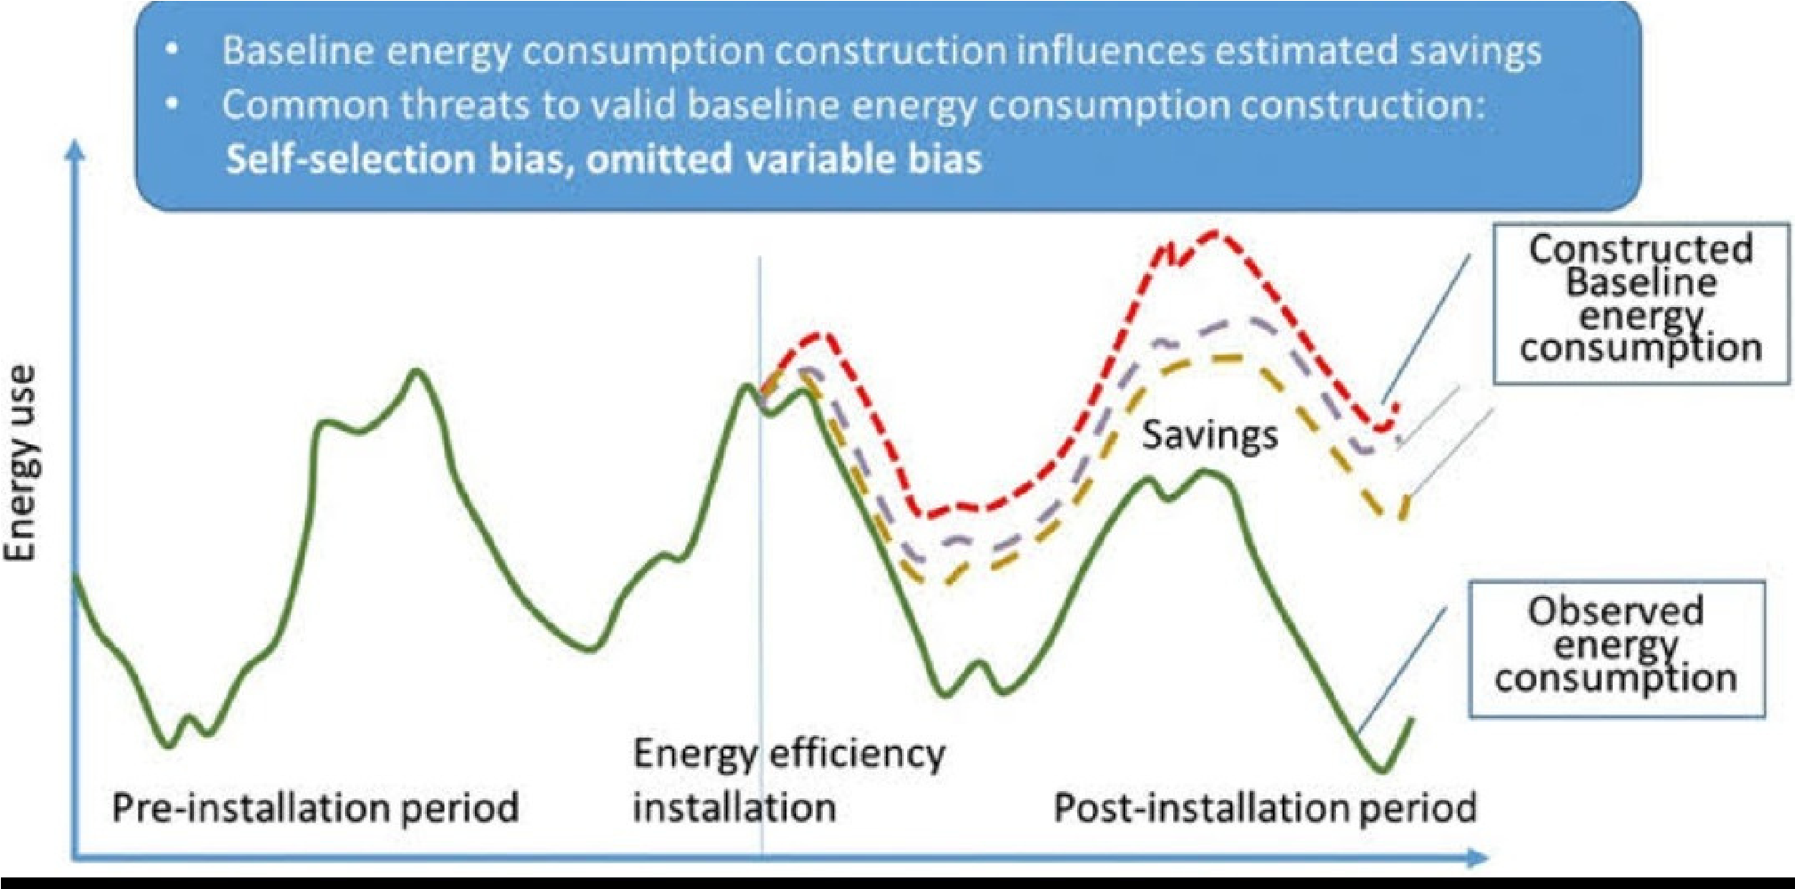

**1.Smart Meter Data:** Smart meters installed in homes or businesses provide detailed data on electricity or gas usage. These data sets include information on energy consumption at different time intervals, which can be used for monitoring and analysis.

1. **Utility Billing Data:** Utility companies maintain data sets that include energy consumption and cost information for their customers. These data are typically aggregated monthly and can be used for billing, budgeting, and overall consumption analysis.
2. **Building Management System (BMS) Data:** commercial and industrial settings, BMS data can provide information on energy consumption, HVAC (heating, ventilation, and air conditioning) systems, lighting, and other building-related energy usage.
3. **IoT Sensor Data:** Internet of Things (IoT) sensors, such as temperature sensors, occupancy sensors, and environmental sensors, generate data that can be used to monitor and optimize energy consumption in various settings.
4. **Energy Auditing Data:** Energy audits involve detailed assessments of energy usage in a building or facility. The data generated from these audits can provide insights into areas for potential energy savings.
5. **Renewable Energy Production Data:** For systems with renewable energy sources like solar panels or wind turbines, data on energy production is crucial for understanding the overall energy balance.
6. **Energy Efficiency Project Data:** Data sets from energy efficiency projects may include information on energy consumption before and after the implementation of energy-saving measures.
7. **Environmental Data:** Environmental data sets, such as weather and climate data, can be correlated with energy consumption to understand the impact of external factors on energy use.
8. **Home Energy Management System Data:** These systems collect data on household energy consumption and provide insights to homeowners on how they can optimize energy use.
9. **Grid Data:** Energy grid operators maintain data sets that show the energy consumption and production at the grid level. This data is important for managing the overall energy supply and demand.

When selecting a data set for measuring energy consumption, it's essential to consider the specific objectives, the scale of measurement (e.g., individual households, commercial buildings, or industrial facilities), and the level of detail required for analysis. The choice of data set should align with the goals of energy management, efficiency improvements, or research in the field of energy consumption.

**Data pre-processing:**

Data pre-processing is a crucial step in working with energy consumption data to ensure that the data is clean, accurate, and suitable for analysis. Here are some common data pre-processing steps for measuring energy consumption.

Pre-processing refers to the transformations applied to our data before feeding it to the algorithm. Data pre-processing is a technique that is used to convert the raw data into a clean data set. In other words, whenever the data is gathered from different sources it is collected in raw format which is not feasible for the analysis.

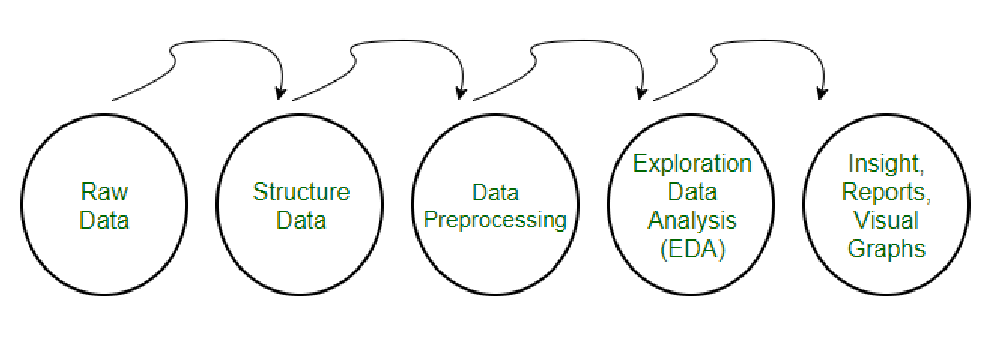

**Data pre-processing**

# Need of Data Pre-processing

For achieving better results from the applied model in Machine Learning projects the format of the data has to be in a proper manner. Some specified Machine Learning model needs information in a specified format, for example, Random Forest algorithm does not support null values, therefore to execute random forest algorithm null values have to be managed from the original raw data set.

Another aspect is that the data set should be formatted in such a way that more than one Machine Learning and Deep Learning algorithm are executed in one data set, and best out of them is chosen.

**Steps in Data Pre-processing**

**Step 1: Import the necessary libraries**

# importing libraries import pandas as pd import scipy import numpy as np from sklearn.preprocessing import MinMaxScaler import seaborn as snsi

Import matplotlib.pyplot as plt

**Step 2: Load the dataset**

Dataset link: [https://www.kaggle.com/datasets/uciml/pima-indians-diabetes-database]

# Load the dataset df= pd.read_csv('Geeksforgeeks/Data/diabetes.csv') print(df.head())

**Output:**

Pregnancies Glucose Blood Pressure Skin Thickness Insulin BMI

1. 6 148 72 35 0 33.6 \
2. 1 85 66 29 0 26.6
3. 8 183 64 0 0 23.3
4. 1 89 66 23 94 28.1
5. 0 137 40 35 168 43.1

Diabetes Pedigree Function Age outcome

1. 0.627 50 1
2. 0.351 31 0
3. 0.672 32 1
4. 0.167 21 0
5. 2.288 33 1

**Check the data info:**

df.info()

**Output:**

<class 'pandas.core.frame.DataFrame'>

Range Index: 768 entries, 0 to 767

Data columns (total 9 columns):

# Column Non-Null Count Dtype

--- ------ -------------- -----

1. Pregnancies 768 non-null int64
2. Glucose 768 non-null int64
3. Blood Pressure 768 non-null int64
4. Skin Thickness 768 non-null int64
5. Insulin 768 non-null int64
6. BMI 768 non-null float64
7. DiabetesPedigreeFunction 768 non-null float64
8. Age 768 non-null int64 8 Outcome 768 non-null int64 **datatypes:** float64(2), int64(7) **memory usage:** 54.1 KB

As we can see from the above info that the our dataset has 9 columns and each columns has 768 values. There is no Null values in the dataset. We can also check the null values using df.isnull()

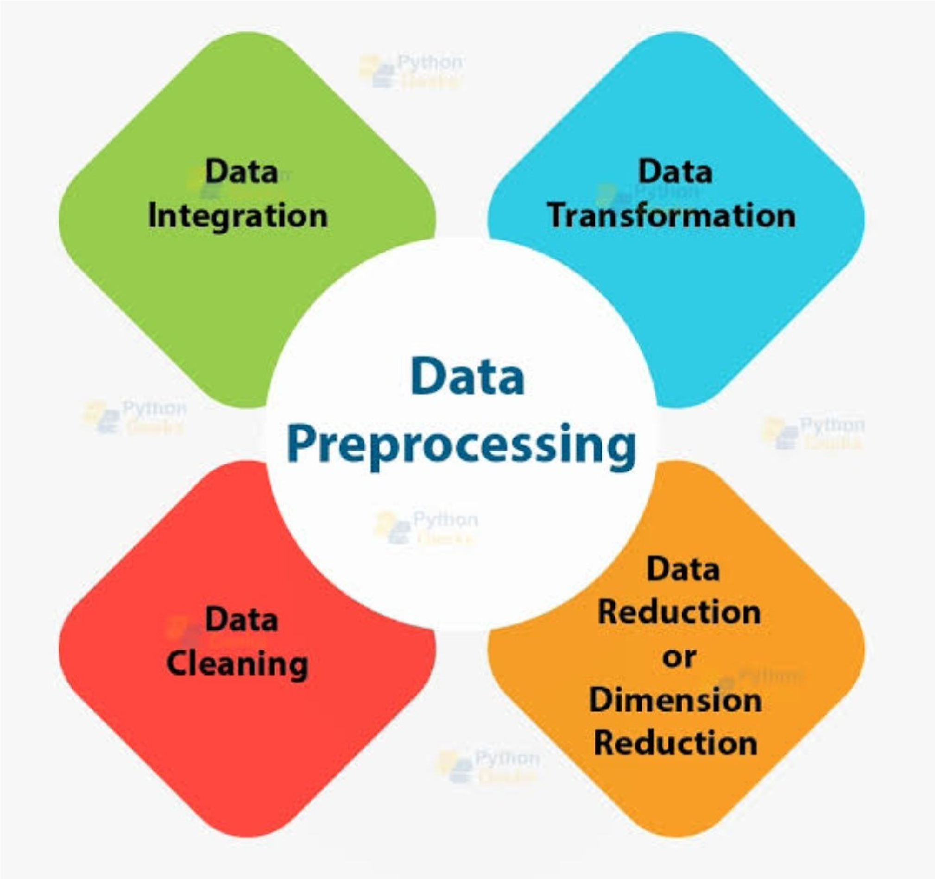

Data pre-processing is a critical step to ensure the reliability and accuracy of energy consumption data, making it ready for analysis, modelling, and decision-making processes in energy management a efficiency improvement projects.

**Data pre-processing visualisation:**

Data pre-processing visualization is a helpful way to gain insights into your energy consumption data and understand the effects of pre-processing steps. Here are some common data pre-processing visualizations you can use:

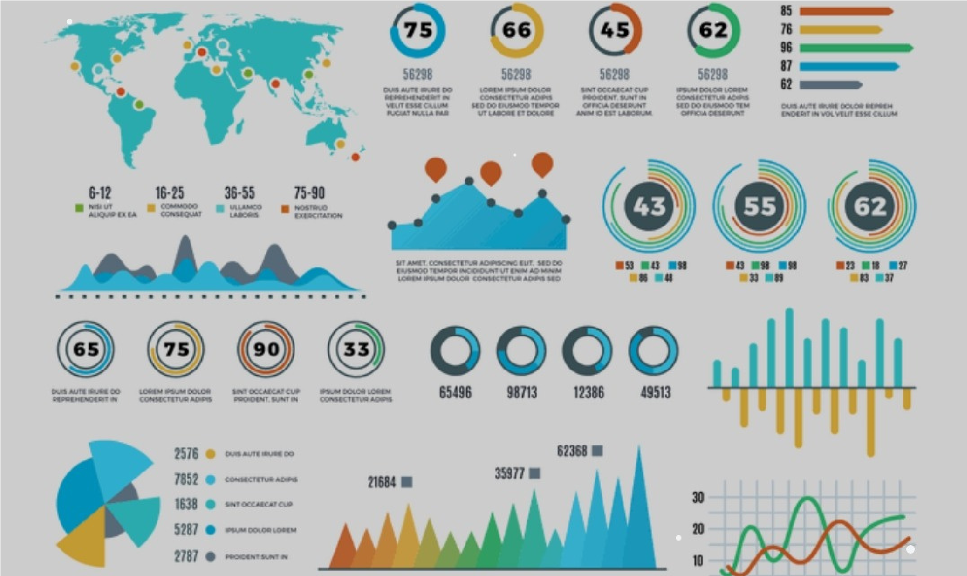

# Data all plots visualisation using python

1. **Histograms:** Histograms can show the distribution of energy consumption values. This is useful for identifying outliers and understanding the overall data distribution.
2. **Box Plots:** Box plots provide a visual representation of the data's spread and can help identify outliers and variations in consumption.
3. **Time Series Plots:** Visualizing energy consumption over time helps in identifying trends, seasonality, and periodic patterns. It's essential for understanding how energy usage changes throughout the day, week, or year.
4. **Scatter Plots:** If you're comparing energy consumption with other variables (e.g., temperature, occupancy), scatter plots can help visualize relationships and correlations.
5. **Missing Data Heat maps:** Heat maps can visually represent missing data patterns, helping you identify which timestamps or variables have missing values that need to be addressed.
6. **Data Distribution Plots:** Use distribution plots, such as Kernel Density Estimation (KDE) plots, to visualize the shape of data distributions and potential multimodality.
7. **Data Correlation Heatmaps:**If you're working with multiple features, a correlation heat map can help visualize the relationships between variables, including correlations with energy consumption.
8. **Data Transformation Plots:** Visualize the effect of data transformations, such as normalizations or scaling, to assess how they change the data's distribution.
9. **Time Alignment Visualization:** If your data comes from different sources or has time synchronization issues, you can plot the timestamps to visualize alignment or misalignment.
10. **Feature Engineering Visualization:** If you've created new features, visualize them to understand their patterns and whether they add value to your analysis.
11. **Quality Control Plots:** Use control charts or other visualization techniques to monitor data quality and identify anomalies or inconsistencies in the data.
12. **Before-and-After Plots:** Create side-by-side plots that show the data's distribution or patterns before and after pre-processing steps to visualize the impact of each such as

**PROGRAM:**

import matplotlib.pyplot as plt import pandas as pd

# Sample energy consumption data (replace with your dataset) data = {

'Date': ['2023-01-01', '2023-01-02', '2023-01-03', '2023-01-04', '2023-01-05'], 'Energy Consumption (kWh)': [100, 110, 95, 120, 105]

}

# Create a DataFrame from the data df = pd.DataFrame(data)

# Convert the 'Date' column to datetime df['Date'] = pd.to_datetime(df['Date'])

# Create the line chart plt.figure(figsize=(10, 5)) plt.plot(df['Date'], df['Energy Consumption (kWh)'], marker='o', linestyle='-')

# Add labels and title plt.xlabel('Date') plt.ylabel('Energy Consumption (kWh)') plt.title('Energy Consumption Over Time')

# Show the chart

plt.grid(True) plt.xticks(rotation=45) plt.tight _layout() plt.show()

**Data visualisation**

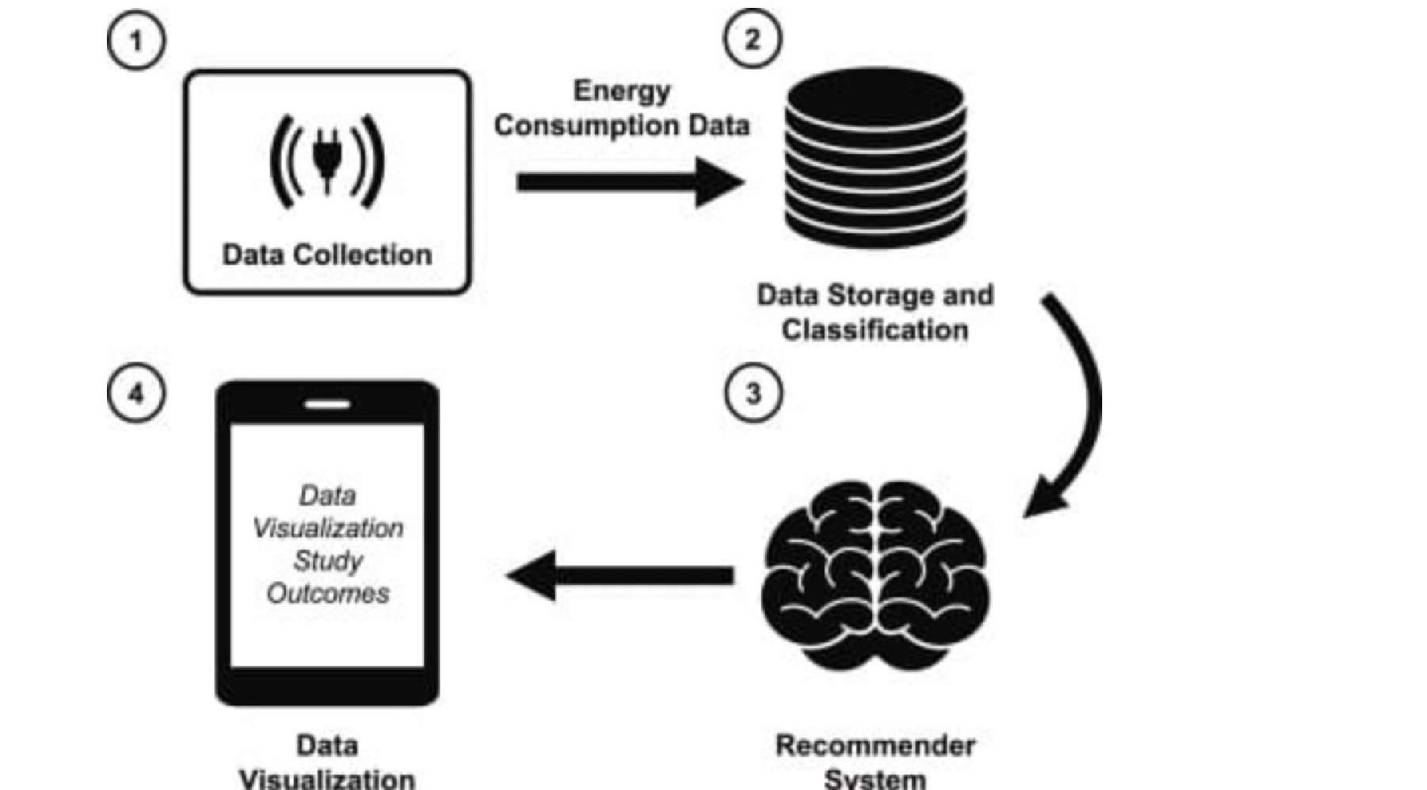

These visualizations can be created using various data analysis and visualization tools, such as Python with libraries like Matplotlib and Seaborn, specialized data visualization software. By using these visualizations, you can better understand your energy consumption data and the effects of pre-processing, helping you make informed decisions for analysis and modelling.

**Development in innovative techniques :**

Sure, here are some innovative techniques for measuring energy consumption:

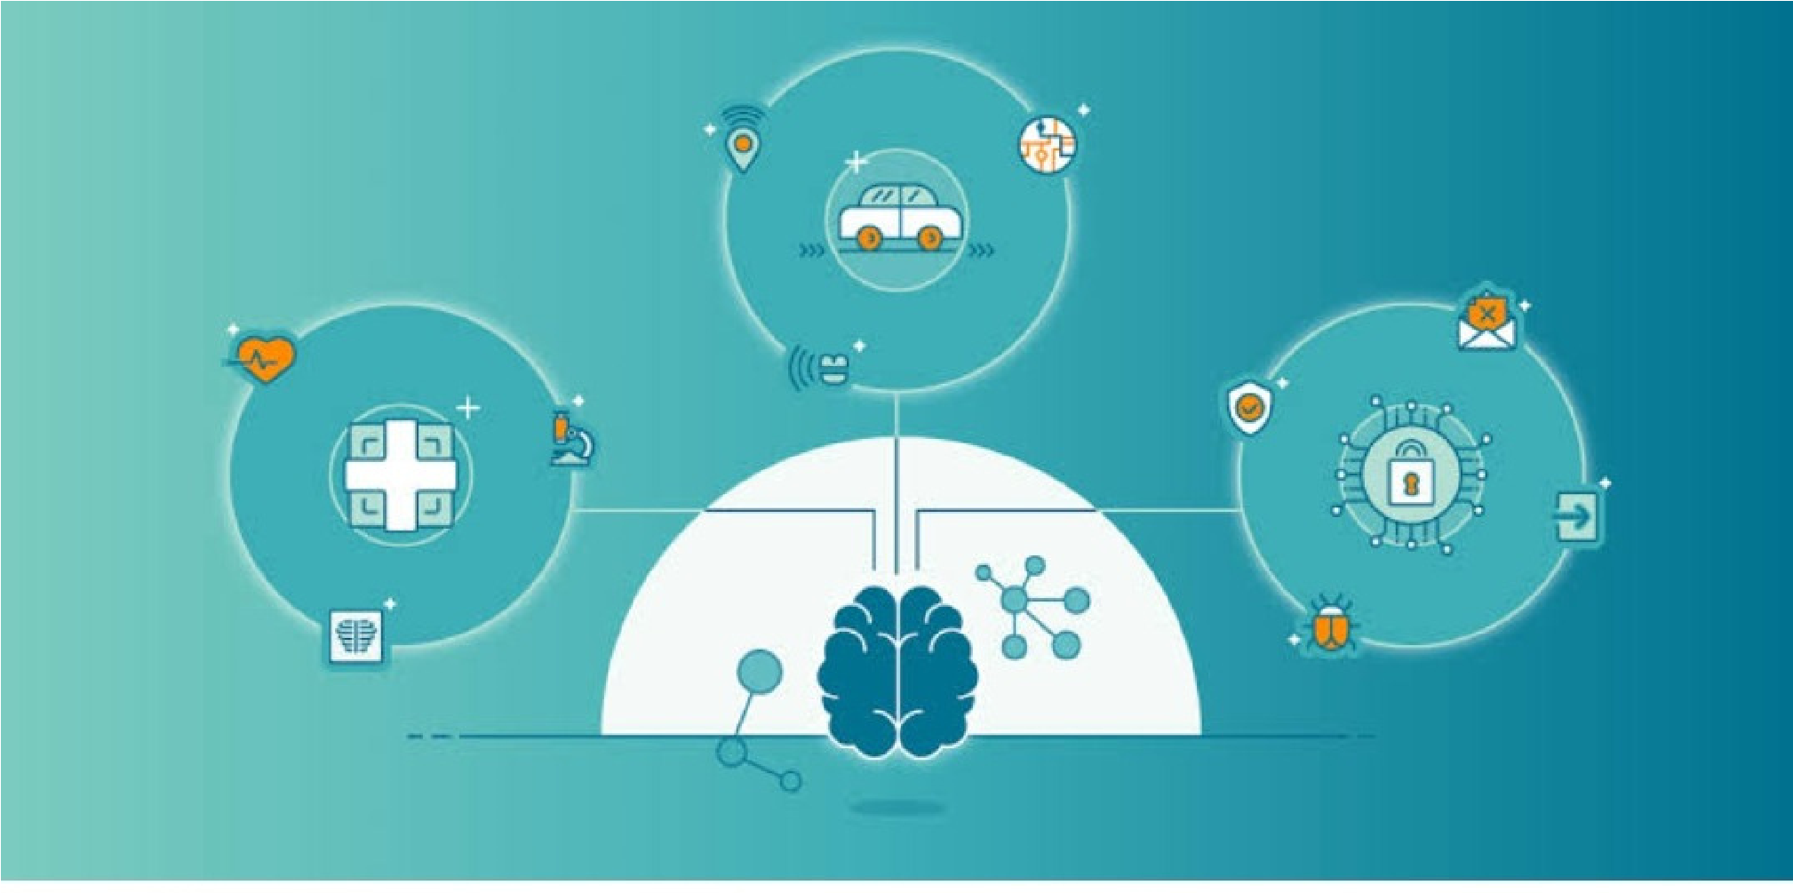

1. **Non-Intrusive Load Monitoring (NILM):** NILM techniques analyze the electrical waveform to disaggregate and measure the energy consumption of individual appliances or devices without the need for dedicated sensors. This can be achieved using machine learning algorithms.
2. **Smart Plugs and Smart Meters:** Smart plugs and smart meters provide real-time energy consumption data for specific appliances and the entire household. They often have accompanying apps or dashboards for tracking usage.
3. **Thermal Imaging:** Infrared thermal imaging cameras can be used to detect heat signatures from appliances and electrical equipment. Abnormal heat patterns can indicate energy inefficiencies or potential faults.
4. **Block chain-Based Metering:** Block chain technology can be used to create transparent and secure energy metering systems. It enables tamper-proof recording of energy consumption and simplifies billing processes.
5. **IoT Sensors:** Internet of Things (IoT) sensors can be placed on appliances or within electrical panels to monitor energy usage. They can transmit data wirelessly to a central system for analysis.
6. **Power Quality Analyzers:** These devices measure the quality of electrical power, including voltage, current, and harmonics. They can help identify inefficiencies and problems in the electrical system that a ect energy consumption.
7. **Machine Learning and AI:** Advanced machine learning and AI algorithms can be applied to historical data to predict and optimize energy consumption, identify patterns, and recommend energy-saving measures.
8. **Eco-feedback Systems:** These systems provide real-time feedback to users about their energy consumption, encouraging them to make more energy-efficient choices.
9. **Wearable Energy Monitors:** Some wearable devices can track personal energy consumption and provide insights into how daily activities impact energy use.
10. **Distributed Energy Resources Management Systems (DERMS):** DERMS help manage and optimize the integration of renewable energy sources, storage systems, and electric vehicle charging to reduce energy consumption and costs.

These techniques are a variety of options for measuring and managing energy consumption, from individual appliances to entire buildings and beyond.

**Conclusion:**

Certainly, here's a more detailed conclusion regarding the measurement of energy consumption:

Measuring energy consumption is a fundamental practice with far-reaching implications for individuals, businesses, and society as a whole. In conclusion, the measurement of energy consumption is a multifaceted process with profound implications. It serves as the foundation for resource management, cost control, environmental responsibility, efficiency improvement, policy compliance, and our collective journey toward a sustainable and resilient energy future. Its significance cannot be understated in our quest to balance energy demand with environmental preservation and economic stability. measuring energy consumption is a crucial step in understanding and managing our energy usage. It enables us to make informed decisions to reduce our environmental impact, lower energy costs, and ensure a sustainable future. Accurate measurement and analysis of energy consumption data are essential for optimizing energy efficiency and promoting responsible energy usage.